**Automated Phonetic Transcription Grading Tool**

**E-learning**

Vishvaa Trivedi

A Master's Project Research Paper Submitted to Graduate Faculty of

Auburn University

in final year Project requirement for

the Degree of Computer Science and Engineering.

Auburn, Alabama

December 2018

Focus: E-learning, Distance Education, Blended learning,

# **ABSTRACT**

E-learning is replacing the educational scenario rapidly nowadays. Getting education is not limited to sitting in a room. Over the years E-learning platform has made a significant improvement in the education system. Online classes, videos have made getting an education or learning something easier than browsing through thousands of pages of a book to find something you want. Online learning is one of the most powerful and effective tools to gain knowledge. Online Learning, E-learning or Distance learning is significantly inexpensive than the physical learning system. Anyone and everyone who can access the Internet from their device can start learning. There are no more restrictions on location and time for teaching and learning. My projects are focused on E-learning or we can say Online learning. We have built a Web-based tool The Automatic Phonetic Transcription Grading Tool (APT-GT) which enriched the experience of the user for learning and teaching. And the other project is Ergonaut Application in which the video of some work upload on the system and then later that video breaks into frames. In which user can customize the data based on the posture, relevant data for the effort of working on something meaningful done then store it in a file which will be useful for the ergonomic model. It’s building to collect the data based on the human interaction and calculate the risk.

APT-GT application allows the students to transcribe the speech of audio samples and their ability to type characters and click on the International Phonetic Alphabet (IPA) keyboard to insert phonetic symbols is scored. The main scenario of the application includes playing audio files of words and students type its phonetic symbol to get a score based on the typed input. For multi-lingual learners, the ALT provides various keyboards with different phonetic symbols, which includes most languages’ phonetic symbol all over the world. It is a web-based application built in a Responsive Web Design framework promoting a User- Centered Design, which allows the students to use the application on desktop, smartphones and other hand-held devices.

# **ACKNOWLEDGMENTS**

I would like to express my special thanks of gratitude to Dr. Seals for supporting me with my graduate study as well as for giving me the golden opportunity to do this wonderful project on the topic of E-learning, which also helped me to develop my User Interface skill and Web developing skill and I came to know about so many new things I am really thankful to her. I would also like to express my sincere thanks to my committee members Dr. Dean Hendrix, Dr. Xiao Qin. I am greatly thankful to you for your time and participation in this study. I would like to thank my team members Robert, Sicheng, Vijoy who works with me through these two projects. Secondly, I would also like to thank my parents and friends who believed in me and helped me a lot in my journey of graduate school. Without them I this was not possible.

**Table of Contents**

[**ABSTRACT……………………………………………………………………………**](bookmark://_Toc511882554)**……………………………………..2**

**ACKNOWLEDGMENTS……………………………………………………………………………………………………….4**

**CHAPTER 1. INTRODUCTION** 7

**CHAPTER 2. LITERATURE REVIEW** 10

2.1 E-learning system 10

2.2 HISTORY OF E-LEARNING 12

2.3First Testing Machine 14

2.4 CLASSIFICATION OF E-LEARNING 16

2.4 Advantages of Online Learning 18

**CHAPTER 3. METHOD** 21

3.1 Current System 23

3.2 Problem in the current system 26

**CHAPTER 4. Implementation** 37

4.1 Required Changes: 37

**CHAPTER 5. IMPLEMENTATION** 40

5.1 Testing: 40

**CHAPTER 6. CONCLUSION & Future work** 42

REFERENCES 43

# **CHAPTER 1. INTRODUCTION**

As per the name, we can easily tell what E-learning is, the name itself describes it. Whatever we learn online, Problems, software, art or even recipes on YouTube is a part of E-learning. This method is widely used in the majority of US universities [5]. This is extremely convenient for a student. If someone misses a lecture due to an emergency, they can get access to entire lecture virtually and they can watch it as many times they want or run it slowly depending on one’s learning capacity.

Online learning or distance learning is not just convenient for a student, but also for the people who didn’t have time or circumstances to attend a college or pursue higher studies after school. If those people now have a family but still wish to finish college or higher studies, they can enroll into university’s online program and attend classes virtually. Students do not have to go to university but can learn and get a degree with their own convenient time and can also balance family. Online learning has been a dream come true for a lot of people. E-learning is also effective in face to face classes. Showing powerpoint slides with the images or diagram of the related topic help to the understanding of the topic easily. Visual aids play an important part in learning.

The idea of distant learning existed even before the Internet. It has been around since Isaac Pitman taught shorthand in Great Britain via correspondence in the 1840’s. In the 1980s, and 1990s computer-based Training was introduced. This is like a foundation of E-learning. The CBT (Computer- Based Training) system requires a personal computer system connected with some other multimedia connection like CD-ROM [2]. The system was good, but it still did not address the limitations for time and place as needed in traditional E-learning system. The key to CBT development was such that, it can be led into the rise of the Internet and world wide web. This is known as web-based-training. WBT system and programs connected to it were spreading widely.

In the beginning, information was delivered only through text. After text-only information, the next phase was to deliver information with graphics. In early 1990, most of the Universities in the United States were ready to begin delivering content through virtual education and created systems to deliver courses online to the people who cannot attend college physically due to certain circumstances. Within a few years, this concept spread widely throughout the world. Some universities preferred building their own systems. This allowed teachers and students to interact in many ways through email, through online testing, systems to track student progress, and systems to support exchange learning materials, etc. The following figure1 is an example of an early online learning system (i.e. Oregon State University online learning system).

A screenshot of a cell phone

Description generated with very high confidence

Fig1- 90s teaching machine[1]

“Discription of this in ch2”

# **CHAPTER 2. LITERATURE REVIEW**

# 2.1 E-learning system

After almost a decade (2000), companies started using E-learning to train their employees. They got an opportunity to improve their knowledge and become more skilled. Also, they were able to access a video from home. Individuals due to this development were able to get a degree from home. E-learning system improved which allowed the teacher to teach and students to communicate with a teacher easily. After E-learning the education system has been completely changing. The new technologies are skyrocketing and learning that technology by using online tools which is available for free is easier than ever. Some of the tools are free and some tools are paid but they offer certification courses, which can give you an opportunity to build your career in it or can find a job in that specific field. Before two decades who had thought of having a virtual world and making 3-D designs online. Anyone can be coder/programmer once they acquire the needed skills.

Before the Internet was widely available, in the marketplace, WBT (Web-Based Training) was famous and programs connected to it were increasing rapidly with “together with the paralogical” approach which started in 2002 to be more efficient with professional management. WBT created positive results for many universities and companies. E-learning has many advantages and it can be effectively used for distant as well as face to face education. Discussion about E-learning program for years 2002-2006 started in 2000. Its main goal was to spread knowledge about new forms of teaching, but mainly to improve the education system [2]. The improvement mainly started in content for new courses and programs for the universities. The subproject ODL NET (open and distant learning for network exchange experiences) played a great role in contact with other countries.

This project was developed in the framework of the European program Socrates, which concentrate on the propagation of distant education based on information and communication technologies. The purpose of this project was to share the experience of new form all over the world. There were eight European countries involved in this project, Great Britain, Ireland, Portugal, Spain, Greece, Finland, Cyprus, and the Czech Republic. [2] The universities participated are:

* Fundación Universidad-Empress de Valencia, ADEIT, Spain – coordinator of the project
* University Hradec Kralove, Faculty of Informatics and management, Czech Republic
* University of Limerick, Ireland
* University of Oulu, Finland
* Portuguese Open University, Portugal

Centre of higher education In theater studies, Greece

* University of Hull, Great Britain
* University of Cyprus, Cyprus

In 2010 and even today, Due to YouTube, Wikipedia, Social media (Facebook Instagram, etc.) we can learn anything from crocheting to building UAVs. Companies and individuals are taking this opportunity to share their knowledge to the world and gain knowledge from others. This is a great platform to grow the knowledge. In the future, E-learning might go a step forward to artificial intelligence.

# 2.2 HISTORY OF E-LEARNING

E-learning name was given to this field in the conference held in Los Angeles in 1999, before that this technology was called virtual learning. With the increase in demand, the price of Internet decreased, so it was affordable was the middle class also. As we know E-learning is growing fast these days, but it was first introduced via a testing machine in 1924. Which was not an E-learning machine, but it was self-testing machine for students.

A close up of text on a black background

Description generated with very high confidenceFollowing the chart describes the evolution of E-learning

**Fig2: History of E-learning[2]**

# 2.3 First Testing Machine

In 1920, Professor Sidney Pressey, education psychology, Ohio State University, made a machine to give students some problems for practice to students in the introductory course. Pressey said in 1926, “The procedure in the mastery of drill, and informational material was in many instances simple and definite enough to permit handling of much routine teaching by mechanical means” [1]. The teaching machine was looking like type writes with showing questions with four answers on the window. The student had to press a key corresponding to the correct answer. After pressing the key, the machine recorded the answer and stored it in the back counter. After recording, a new question pops up. After finishing all the questions, the student sleeps back the sheet into the device and note the score on the counter [1].

A close up of a machine

Description generated with high confidence

**Fig3: Pressey’s Machine [1]**

# 2.4 CLASSIFICATION OF E-LEARNING

In the Information Technology, Communication Technology, Department of social science and technology, and the development of the education E-learning has rapidly grown in people’s favor. Many types of research have proved that online learning is educating people more than going to specific classrooms. The current education system is in the transition from old paper-based learning towards electronic learning. Classrooms of today are equipped with a blackboard, markers as well as with screens and projectors. Teachers can now display or show a PowerPoint presentation on projectors and solve equations on the board. The face-to-face learning and distance learning they both are increases the usage of E-learning tools. According to Research trends [6], E-learning can be classified into two types: 1). Complete Online Learning & 2) Blended Learning.

Complete Online Learning: The name of the type says itself that this type totally depends on online-based education. Everything online, the course material. Assignment, project work, group study, exams, etc. There are some tools which provide one to one tutoring in that a person sitting another side of the world can tutor-student who needs help with some course. That provides flexibility in learning, especially who left school or college to work and feed their family, or someone who wants to learn more but doesn’t have time to go to school fulltime. This platform has been used by Auburn University in form of Panopto Recordings [7]. Which has been used by so many students who enrolled as distance learning student. It provides the flexibility to students about place and time of learning.

Blended Learning: Blended learning is a hybrid learning type. There are some factors which available face-to-face method but sometimes it reduces the contact and uses the E-learning tool. As the best example of it, in Dr. Thomas class of Game Design for Social Change, we learn some modules in class but then professor uploads a detailed lecture online on playpoist.com, where the student watches that video and give the answers according to questions while learning.

However, there are some drawbacks of online learning. When you go to a traditional classroom, you can clear your doubts on the spot by asking questions to your instructor, you can ask your friend to explain. But in distance learning, you must wait until another person is available to solve your doubts.

# 2.4 Advantages of Online Learning

According to research trends [6], there are several types of benefits by learning online.

1. **Global Connectivity:**

E-learning has changed the traditional education type. By learning online, you have access to huge resources. E-learning is like having access to a virtual library and you don’t have to go to the library physically, but you have all the textbooks, articles etc. you need. Information is just one click away from you. Libraries are also social spaces where a person can connect with others. Today we can connect globally, and he/she can have friends online through social media. They can have group session by connecting via e-mail, online group chat platform or video conference call. Online learning provides worldwide knowledge to students who are eager to learn and provide new opportunities for teachers to more broadly share their knowledge.

1. **Quick Access:**

When we are learning online this is a benefit and is very useful and important. We can have several resources from e-library and by searching them on the Internet. Also, we can get numerous resources and get them at any time. E-books, E-generals, audio-books, etc. are widely available. There is no headache of going to the library and searching through piles of books to get the one you want. Even students can access their course materials, precious test and exam materials.

1. **Convergence of different Mediums:**

As an online student, you get different types of medium to provide education or to get an education in one place. As described in research trends [6] such as text, graphics, audio, video, virtual and email. These mediums can be useful to do group discussions, help to learn materials. It really breaks the limitation of learning and understanding of material which used to de just traditional.

1. **Flexibility**:

Online learning gives you the flexibility of the time and place to learn. It is very important for the students to understand the material and course. In the traditional system you must attend classes and if you miss some classes, then you cannot understand the rest of the materials. E-learning provides you the flexibility of greater access. Whenever you get a chance, or you have time you can start learning anywhere. Students can access the recorded video and audio files. As Auburn University provides their students Panopto Recordings [7], which saves the lecture online and students can access easily whenever they want. The flexibility of these recordings is if students have a question in the middle of the night, students can just pull that lecture from the recordings and review that lecture again. If you even miss a class, you can review that video. Online learning even provides students opportunity to take exams online. Students have much more flexibility because of E-learning tools. Students can schedule their exams according to their availability.

1. **Ability to serve a large number of students at low cost [6]:**

Education is very important for everyone; each person deserves a basic education. But all of them cannot afford it and especially when higher education is very costly. In some countries there are not enough schools and universities to provide more access for students to seek a better education. There are many people who want to gain knowledge but either they don’t have the funds to spend on University education and they don’t have access to enough facilities which can provide education. Therefore, E-learning education tools are a perfect platform for the quality education and low-cost education.

# **CHAPTER 3. METHOD**

The APT-­GT is an interactive learning environment that connects students with the linguistic course faculty. It provides educational and lesson information in the form of videos uploaded by the faculty under assignments and each assignment will have a video examination and practice test. The lesson files are in video format and the questions added to the examinations and practice tests are the audio format. The teacher will have a user account for himself using the APT-GT account. And those file of lessons and exams will be managed by the faculty or TA only. To login and access, the functionality, a student must register with the APT-GT. The students must then register for a course he/she is willing to attend. The faculty will approve the registration of the student, after which the student will be able to access the course material, examinations or practice tests related to the course. The faculty will approve the registration of the students, after which the students will be able to access the course material, examinations or practice tests related to the course. When a student reviews a video for a specific course and wants to take a practice test or exam, the questions are found in the form of audio files. The student uses the transcribe keyboard only for his answer. Also, in this application, we have a grading tool, which compares students given answer with the professor’s answer and then according to professor’s answer grade them.

APT-GT v1.0 was developed to include all these features. The APT-GT is a web application that allows teachers to create an account, manage lessons and exams, manage students and approve their registration in a specific class. APT-GT allows students to register, use these credentials and register for a particular course. Students can access the course materials, try practice tests for which the results can be accessed immediately and exams for which the results can only be accessed after the due date.

# 3.1 Current System

The APT-GT Version 1.0 has been completed functionally. It provided an interface for all the teacher and the student requirements. The APT-GT has separate functions for teachers, students, and an administrator.

Tasks for the users has been given follows.

1). **Admin:** The user management is carried out by an administrator. An administrator will access APT-GT to authorize new registered users, assign their roles such as student or teacher and, if necessary, remove or disable users.

2). **Teacher:** The teacher accesses the APT-GT primarily to provide students with materials, examinations and practice tests related to the course. As well as they are responsible for the management, modification, and creation of lessons, tests, and examinations for a specific course.

3). **Teaching Assistant (TA):** They can make modifications and changes to the given files. Tests and practice tests. They got assigned by the professors to the particular class.

4). **Student:** Responsible for the consumption of content uploaded by teachers and examinations. Students are administered by teachers, their registrations also approved by the teacher, only after which he /she has access to the course material, tests and examinations.

Fig: Login Page of Current System Fig: Registration Page of Current System

The APT-GT also has a special virtual keyboard which supports the International Phonetic Alphabet (IPA) based on the Latin alphabet. It was designed as standardized by the International Phonetic Association around 19thcentury. The purpose behind designing this keyboard was to represent the standardization sound of spoken languages.  The IPA is used by [lexicographers](https://en.wikipedia.org/wiki/Lexicography), [foreign language](https://en.wikipedia.org/wiki/Foreign_language) students and teachers, [linguists](https://en.wikipedia.org/wiki/Linguistics), [speech-language pathologists](https://en.wikipedia.org/wiki/Speech-language_pathology), [singers](https://en.wikipedia.org/wiki/Singing), [actors](https://en.wikipedia.org/wiki/Actor), [constructed language](https://en.wikipedia.org/wiki/Constructed_language) creators and [translators](https://en.wikipedia.org/wiki/Translation). The IPA is intended to represent only those speaking qualities that are part of the oral language such as telephones, phonemes, intonation and this parathion of words and syllables. There is a set of symbols for the different quality of speech which includes the tooth gnashing, lisping and sounds made by the cleft lip and cleft palate.

# 3.2 Problem in the current system

The APT-GT is in developing stage while it has been used by the Liberal Arts Department. There are some of the changes required in the current system.

1). The first change is to remove the circle and the text from that, in the teacher’s main page and make it a simple menu.

Fig: Teacher’s Main Page view

2). The next is in the teacher’s account, the instructor cannot see the individual courses on the menu. It has all the assignment showing up in the current course page. Instructor needed to see the separate courses and, in that view, he /she supposed to see his individual assignments assigned by him/her to the students.

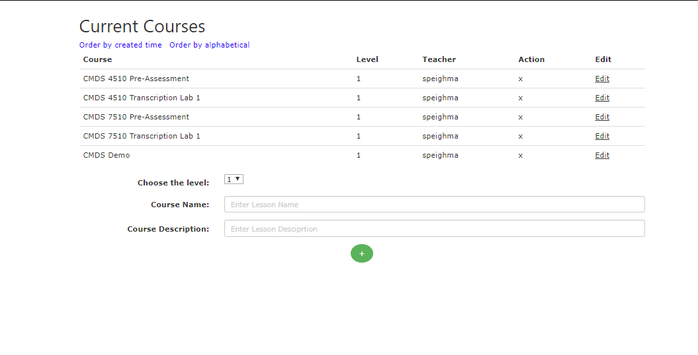

Fig: Current Courses view

3). The other problem was with the file uploading page. As in this web application instructor can upload files / choose files from their device but during this time it was not working properly, it was not able to take a file from the device and save it on the database.

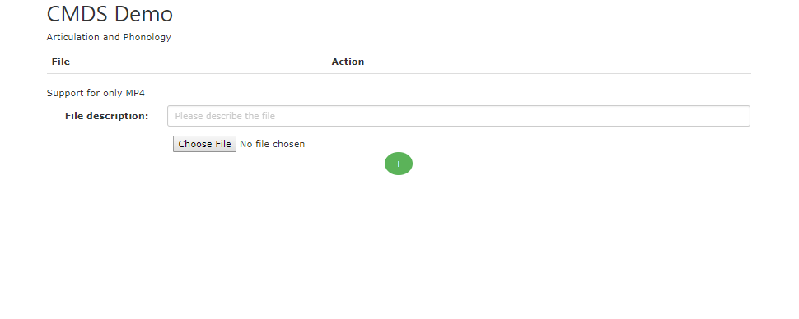

Fig: File Upload page

4). The other problem was with adding students to a particular class. In which instructor was having an error where she/he has to add them again after they added the students manually. Sometimes it happens when a person doesn’t know how to add it but our job was to make sure that we satisfy our user with the minimum clicks and better user interface.

Fig: Adding Students in the class

5). The next problem was with the page functionality of Archived Semester. In where the instructor was having trouble adding students to each class’s assignment and creating a unique id for Class ID. The requirement was that we need to provide a better solution for that so a person how to navigate. The instructor wanted to just copy the existing class and add it to the current semester.

Fig: Archived Semester page

6). The other problem was with the input keyboard. Where instructor was taking the test of page he/ she skipped the word and she wanted to input the sequence of the words, but rather then putting it in there she has to delete the whole answer and then she put the word which she wanted before all of that text and then she entered the whole answer again. Here we needed to implement the function where the user can edit the answer and the previous answer also stays remaining.

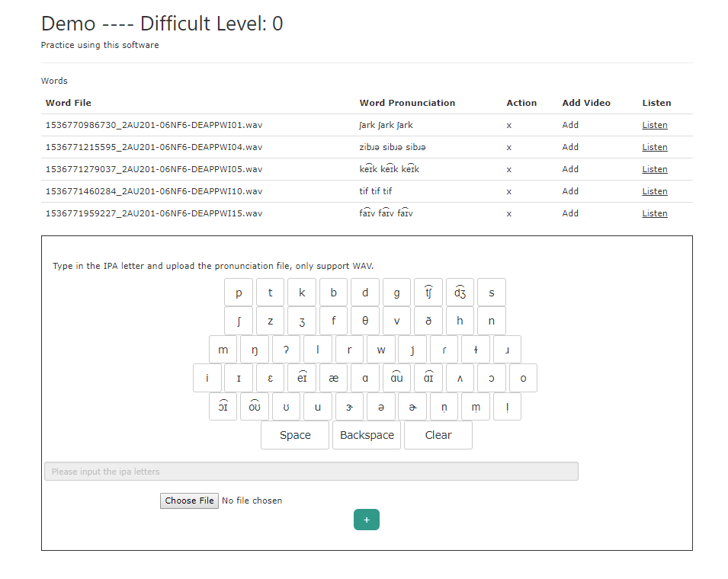

7). The next problem was some of the student's answers were not recording. It was the confusion between the two buttons. Where there are two buttons called Save and Next. The functionality of those buttons was a bit confusing. As if a student clicks on the save button then only answer get saved but if student clicks on the next button then answer don’t get saved and student moved on to the next question. In the result, the score of the student was 0.0 as it was not saving anything.

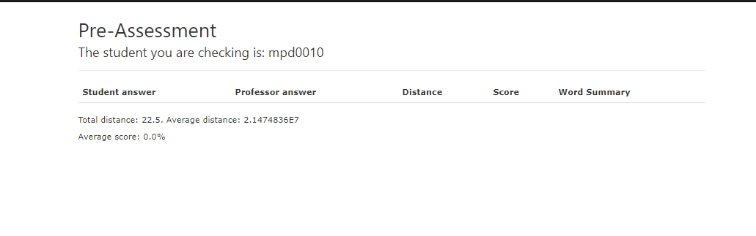

Fig: Student Result page

8). The next problem was instructor was able to see the student’s names in the result page where instructors supposed not to see the name or id of the student at all. The page was showing every detail of the student.

Fig: Hide Student Details

9). The main page change is to remove the circle and the text from that, in the student’s main page and make it a simple menu. With the logo and one button.

Fig: Student’s Main Page

10). In the learning lesson’s page, the heading is “Registered Lessons” where it needs to be changed to “Assignments”. So, students don’t get confused with the lesson details.

Fig: Registered Lessons

11). In the student account after you select the assignment the new page shows up where heading needs to be changed, “Lesson List” to Assignment and “Take Exam” to Exam. Headings really matters for the user. As they are the path and navigation of the page.

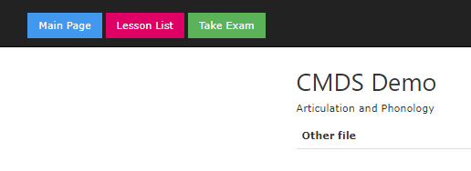

# **CHAPTER 4. Implementation**

# 4.1 Required Changes:

Teacher’s view has been changed to the simple menu list. As given in the picture it has a simple logo on the top and 2 required buttons as the user’s requirement. This view has better UI and easy navigation. Here is the attached screenshot of the first problem, in which the client wanted a better view and change in interface. APT-GT allows students to register, use these credentials and register for a specific course. Students can access the course materials, try the practice tests for which they can immediately access the result and also exams for which the results can only be obtained after the due date. Student’s can compare their answers with the instructor’s answer.

The application should be extended or extended so that teachers can copy or duplicate a course in another course, along with course materials such as videos, practice tests, and examinations, and exclude student data. The APT-GT is a web application that allows teachers to create an account, manage lessons and exams, manage students and approve their registration in a specific class. The grading tools allow teachers to provide course materials via an online medium, which makes it easier for students to access the material. The application should allow a teacher to edit the course details, such as the name, description, start date and semester, easily and easily. The application should contain a splash page for tasks accessible to students. The student should be able to take a practice test or examination with each assignment.

Fig: Update Teacher’s View

In the application should allow a student to see the results of a past assignment for which the student has already taken the examination. The application should have a transcript page to listen to and/or watch a video and transcribe the answers based on the question. The application should be able to provide either a teacher or a student with the ability to access profile settings such as password change, profile image, etc. The application should give the user the ability to get the missed password. The application should allow a student to see the progress bar for the examination or practice test, depending on the number of questions answered, rather than the number of questions. The progress bar should also indicate that the student skipped a question during a test/quiz. The application should give the user the ability to get the missed password. The application should enable a teacher to view the examination/practice test results for each student and also to provide an overview of all students in a particular course.

# **CHAPTER 5. IMPLEMENTATION**

# 5.1 System Scenario and Script for Manual functional Test:

1). User Sign In/Register:

When User ABC opens the first page of the system, ABC will enter the username and password. If ABC doesn't remember the password. To change the password, he/she can click " forget your password?" button. If the ABC is a new user and doesn’t have an account to the website, he/she can go to the “New User? Create an Account” where that person goes to the registration page and insert her required details in it. However, until the ABC registers, he/she cannot move forward.

2). Admin:

An Admin User ABC can sign in to the ALT system using his/her auburn credentials. Once ABC signs in, he/she will be directed to the home page from which user management can be done. As an admin, he/she has multiple responsibilities for the website. Some of them as given below.

* An admin can approve newly registered user.
* Giving new users an appropriate role according to their requirement. Such as Student/ Teacher
* Admin can modify those roles as well.
* Admin can disable and enable ABC user’s permissions on the ATL system.

3). Account Settings:

User ABC can modify his/her account sitting by clicking on the profile picture on the top right corner of any page. he/she will be redirected to the account setting page, where ABC can edit his/her information like name, email address, phone number, and possibly change their account password. User ABC can also change the profile picture and upload his/her own. Finally, user ABC can press the “Save” button to save changes, from which will be directed to the home page.

4). Teacher Lesion page:

One ABC clicks on a particular lesson, he/she will be directed to the lesson page from which ABC can view files from lesson y, ABC can update a file by clicking the " Update" buttons that match that particular file, and he/she can also delete a file by pressing the " Remove" button that matches that file. Lastly, ABC can use the side menu from any tab of a particular lesson to go to any other related tab like homepage, exams page, manage users page, and manage videos page.

5). Student User:

Students will be login using their auburn credential as a student.

Student ABC registers an account. ABC logs into his account using his credentials. ABC reads teacher's announcements and answers if necessary. ABC goes to the lessons page and picks a lesson. ABC watches videos for the lesson. ABC takes related practice tests.

# **CHAPTER 6. CONCLUSION & Future work**

The Automatic Phonetic Transcription Grading Tool (APT-GT) is an application based on a language learning system for a Linguistics course offered at the Communication and Disorders department in the College of Liberal Arts, Auburn University. We have included International Phonetic Alphabet (IPA) keyboard features to make sure students have no difficulty in submitting their online quiz, viewing assignments and submitting these assignments. On the other hand, side, the APT-GT portal also helps teachers in providing a better user interface towards performing their daily activities. For example, teachers can now submit a quiz online in English and the system will auto-generate the quiz in audio. This feature is not only helpful to the teacher but also very helpful to the students.

In the future, we will design and implement more functionality to make the APT-GT suit the needs of the teachers as well as the students. The APT-GT should also be available as a mobile application in both iOS and Android platforms.

# REFERENCES

1. ‘Fundamentals Of E-learning,  [Creative Commons Attribution-NonCommercial-ShareAlike 2.5 License](http://creativecommons.org/licenses/by-nc-sa/2.5/)
2. ‘History and Perspective of E-learning’, Sarka Hubackova
3. ‘A Brief History of E-learning’, Terry T Kidd, Texas A&M University
4. ‘The History of E-learning’, Adit Ruparel
5. ‘Applications of Innovative Technologies on the E-learning system’, Jianxia Chen, Cleve yeo keng, chunzhi Wang
6. “Research Trends in E-learning” Poonam Gaur.
7. <http://wp.auburn.edu/biggio/panopto/>: Panopto Recordings
8. Free JavaScript training, resources and examples for the community. (n.d.). Retrieved from https://www.javascript.com/
9. Goodrich, G. (2017, October 24). Understanding the Model-View-Controller (MVC) Architecture in Rails. Retrieved from https://www.sitepoint.com/model-view-controller-mvc-architecture-rails/
10. Otto, M., & Thornton, J. (n.d.). Introduction. Retrieved from https://getbootstrap.com/docs/4.1/getting-started/introduction/
11. HTML. (n.d.). Retrieved from https://www.w3schools.com/
12. (n.d.). Retrieved from https://www.sqlite.org/index.html
13. Cloud9 IDE. (2018, September 14). Retrieved from https://en.wikipedia.org/wiki/Cloud9_IDE
14. Khaddage, F., Müller, W., & Flintoff, K. (2016). Advancing Mobile Learning in Formal And Informal Settings via Mobile App Technology: Where to From Here, and How? *Educational Technology & Society, 19* (3), 16–26.
15. Yeonjeong Park (Virginia Tech, USA, 2011). A Pedagogical Framework for Mobile Learning: Categorizing Educational Applications of Mobile Technologies into Four Types
16. Chientzu Chou Lanise Block Renee Jesness (2012). a Case study of Mobile Learning Pilot Project in K-12 schools. *Journal of Educational Technology Development and Exchange (JETDE),* Vol. 5: Iss. 2, Article 3.
17. Amantia Pano, Daniel Graziotin, Pekka Abrahamsson. What leads developers towards the choice of a JavaScript framework? Jun 2017
18. W3C working group note, 11 Feb 2004, <http://www.w3.org/TR/2004/NOTE-ws-arch-20040211/>
19. Tallent-Runnels, M. K., Thomas, J. A., Lan, W. Y., Cooper, S., Ahern, T. C., Shaw, S. M., & Liu, X. (2006). Teaching courses online: A review of the research. *Review of Educational Research, 76*(1), 93-135.
20. Udacity. (2015). Retrieved from <https://www.udacity.com/>
21. Wallace, R. (2003). Online learning in higher education: A review of research on interactions among teachers and students. *Education, Communication & Information, 3*(2), 241-280.
22. Wang, Y. D. (2014). Building student trust in the online learning environment. *Distance Education, 35*(3), 345-359.